2

Designing Your API

In the previous chapter, we have learnt about MuleSoft and its capabilities. Also, we’ve gained some insights on APIs, API-led Connectivity, and what we’re trying to build – the API Network.

After having a basic understanding of the fundamental concepts of MuleSoft, in this chapter, we shall learn about the Lifecycle of an API Design, compare various API Design Modelling Languages and learn various aspects of API Design and API Fragments also get an hands-on practise designing an API Specification using the RESTful APL Modeling Language (RAML).

API Design being a primary and a crucial step towards building a successful Application Network, the goal of this chapter is to enable you to design an API using the best practices and industry standards.

…

What you can expect from this chapter:

* Understanding the Anypoint Platform’s Design Centre
* Lifecycle of an API
* Designing your first API using RAML
* Hands-on experience with your API Design
* Best Practices and guidelines to design an API

Before getting started with the actual API Design, let us first understand the fundamentals of an **API Design Lifecycle.**

**Understanding API lifecycle**

…

In order to build a complete API, we need to follow a systematic approach. Hence, we shall now learn about the lifecycle of an API. It consists of four stages:

1. Design: It involves architecting the basic skeleton of your API. This is the first and the most crucial step, as we need to take into consideration all the functional and non-functional requirements to build a logical structure.
2. Simulate: After having a fair understanding of the initial requirements, we need to implement the API by using appropriate endpoints, methods, datatype, examples, and follow the API Design Best Practices.
3. Feedback: Once our API model is ready, we can simulate our API using the mocking service. Also, we can test our API to check if the response meets the initial requirements.
4. Validate: At this stage we will share the API with other external/internal developers and collaborators and take into consideration the feedback received from them. Later we shall introspect the received feedback and implement the API design changes accordingly.

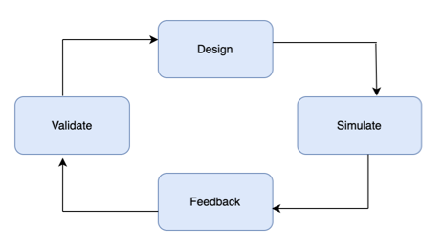

Figure 2.1 - API Design Lifecycle

As we can see in the Figure 2.1, t consisting of four stages

After understanding the various stages of API design lifecyle, we shall now focus on the key elements pertaining to API design which are HTTP, REST and SOAP.

…

///

Introducing REST, HTTP and SOAP

…

REST and SOAP are two different approaches to implement an API design and HTTP is the data transfer protocol which supports REST APIs. In this section, we shall learn a bit more about them.

requirements

REST

**REST** stands for **R**epresentational **S**tate **T**ransfer. It represents a modern architectural style for designing an API.

Features of REST API:

* REST API accommodates stateless client-server architectural model, and the data is transferred over HTTP/HTTPS protocol.
* It supports several datatypes like XML, JSON, plain-text, and HTML, which makes it easily consumable. JSON is the most widely used datatype as it’s a human readable language.
* It is lightweight and compatible with most of the latest technologies.

HTTP/HTTPS

HTTP, short for Hypertext Transfer Protocol, is a client-server communication protocol used to exchange data in a client-server architecture model.

HTTPS is identical to HTTP but has a security add-on. It supports transport layer security ([TLS](https://en.wikipedia.org/wiki/Transport_Layer_Security)—a secure sockets layer (SSL) handshake—encryption to exchange data securely between the client and the server.

The Figure 2.2 depicts how a typical HTTP request/response looks like.

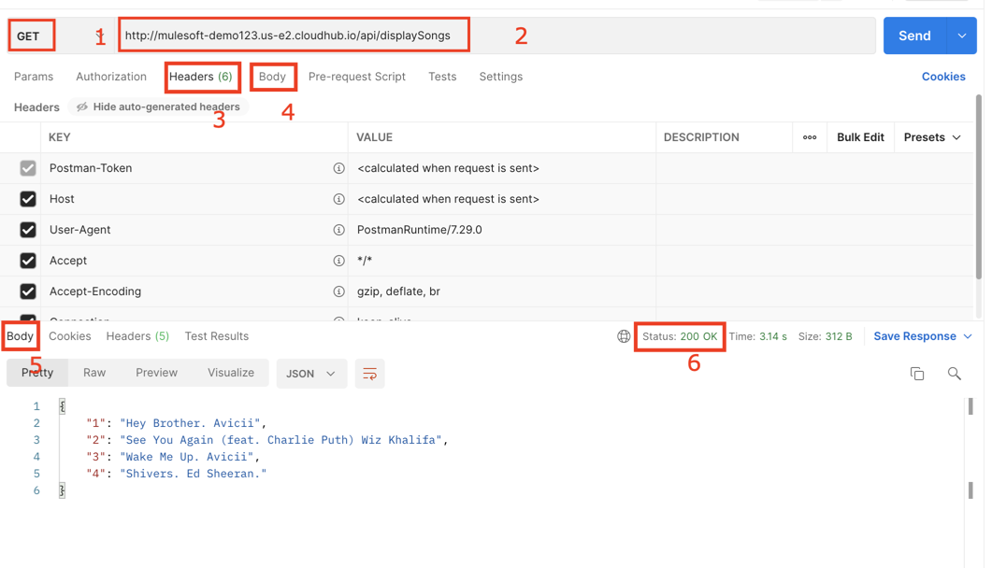

Figure 2.2 - Snapshot from Postman tool depicting HTTP request

The Figure 2.2 tells us about the HTTP request triggered from Postman tool. We shall now understand the various elements of the HTTP request-response with the help of above figure.

The prime elements of a HTTP/HTTPS request-response are:

* Method: It is a verb which defines what action is to be performed. Most commonly used methods are GET, POST, PUT, PATCH, and DELETE.
* URL: Uniform Resource Locator abbreviated as URL, is an address to send request from the client to get service from the server. It contains all the information related to host, port, domain and the endpoint.
* Headers: This is an optional part of HTTP request, which carries additional data/meta-data related to the request.
* Request Body**:** Methods like POST, PATCH, PUT, and more carry data in the form of body. HTTP supports various formats like text, JSON, XML, HTML and so on.
* Response Body**:** It gives us the response returned by the server. Similar to the request body, it supports several formats.
* Response Status**:** The status code indicates the state of the response such as 200 OK success status, 404 Not Found, 500 Internal Server Error, and so forth.

…

As we’ve now understood the REST API and the HTTP protocol, let’s learn more about SOAP API.

///

SOAP

**SOAP** stands for Simple Object Access Protocol. It’s a protocol widely used to communicate between different applications. SOAP API uses WSDL (Web service Definition Language) which is an XML based contract between client and server. It contains all the relevant information related to the webservice, endpoints, request-response, security etc.

Features of SOAP API:

* It can handle requests using several protocols like HTTP, SMTP, TCP etc.
* SOAP supports only XML format.
* It is more secure as compared to REST and complies with ACID properties (Atomicity, Consistency, Isolation and Durability).
* The structure of SOAP API is a bit complex and there is an overhead to manage it.
* Most of the legacy applications use SOAP API.

…

After understanding the features of REST and SOAP APIs, and the HTTP protocol, we can select the respective API Modelling language which can be OAS or RAML, as per the organization use-case.

Let us know learn more about the OAS and RAML

Getting started with OAS and RAML

Open API Specification (OAS) and RESTful API Modelling Language (RAML) are the two most extensively used API description formats. Anypoint Designer lets you create a REST API using RAML or OAS (previously known as Swagger)

Although they both have a lot in common, it’s essential to understand the capabilities of both OAS and RAML, so we can choose our API specification language wisely.

OAS

It’s an open-source specification language founded in 2010 with a huge community support. Its fundamental purpose is to keep API documentation, libraries, and code in sync.

* It supports both JSON and YAML to design API.
* OAS would be ideal if your application has response type only json, as it takes a longer time to load other formats.
* It is not very feasible in terms of code fragmentation & reusability.

Focusses more on the documentation of an API.

RAML

It’s founded by MuleSoft in 2013 with a goal to provide all the relevant information pertaining to an API at one place thus supporting the entire API lifecycle stage.

* It uses YAML, which is a human-readable markup language and thus makes RAML easy to build and manage.
* External files could be imported into RAML, and it supports several data formats with ease.
* Reusable & composable nature of RAML, make it an appropriate choice for users who’re working on a large enterprise project and would like to keep their API lightweight.

RAML being released by MuleSoft, supports the basic concept of API-led connectivity and the API lifecycle management. Hence, Anypoint platform is more inclined towards MuleSoft. But on the other hand, if you’re looking for industry-wide used specification then you can opt for OAS, which has a large community base.

…

Getting started with API design

In order to get started, go to Anypoint Platform Signup Page, where you can create a free trial account for 30 days.

You can click here to create a free account: https://anypoint.mulesoft.com/login/signup

Note

In case you’re using your organization’s Enterprise Anypoint Platform account, make sure you have correct access right to Design, Publish, and Deploy the API.

Follow these steps to get started:

1. Enter your details and sign up (see Figure 2.3).

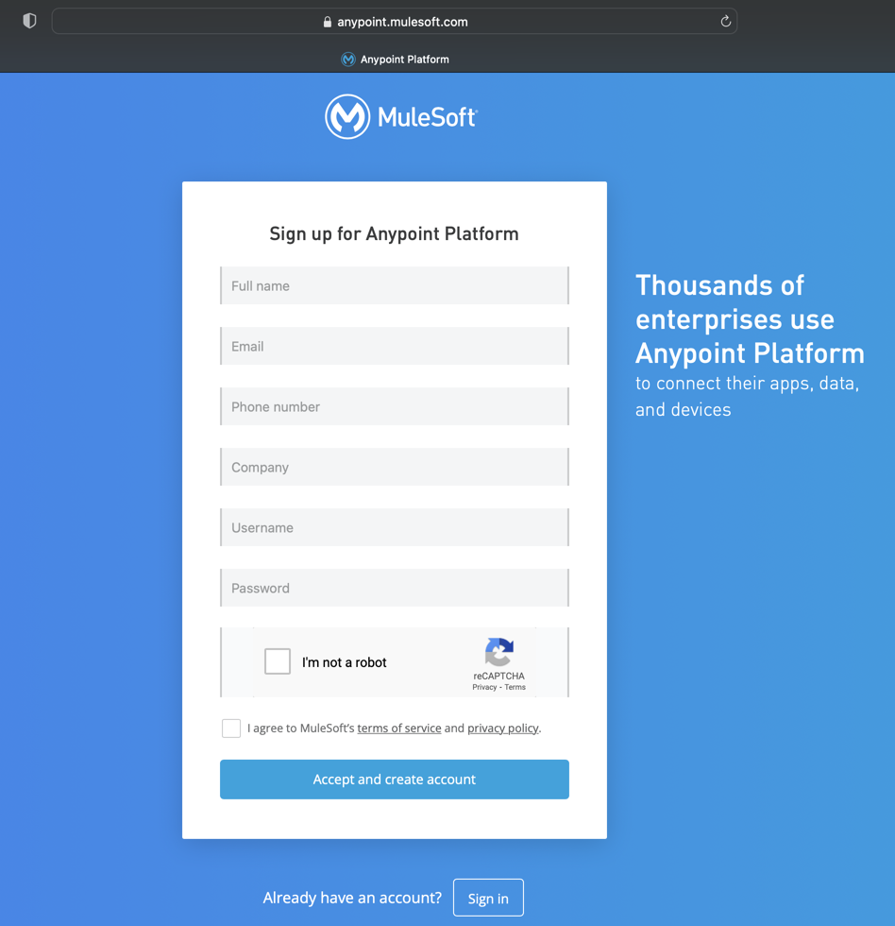

Figure 2.3 – Anypoint Platform Sign Up Page

1. Once completed, you’ll be taken to the homepage of the Anypoint Platform – MuleSoft’s iPaaS platform. Navigate to Design Center from the three dashes on the left corner of the homepage (see Figure 2.4).

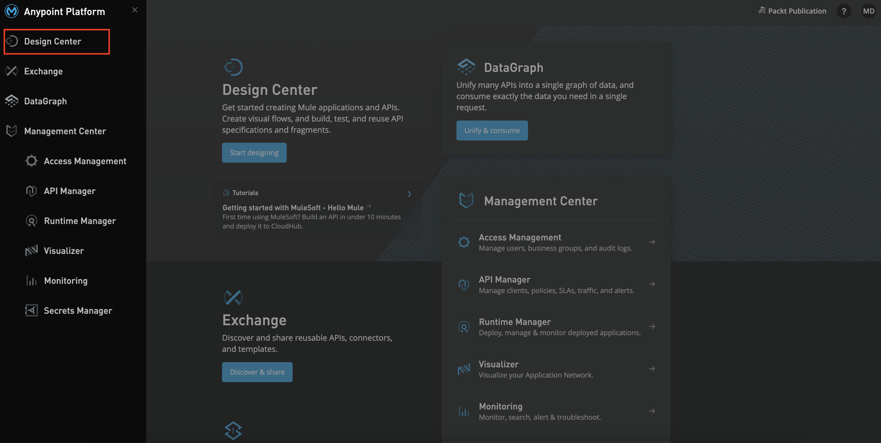

Figure 2.4 - Anypoint Platform Dashboard

You can start writing your API using any simple editor, but it becomes a bit hectic to manage the API and its dependency. Hence, we will design the API using the Anypoint Platform’s Design Center

1. When you click on Create new button in Design Center (see Figure 2.5), it gives you multiple options to create:

* New API Spec**:** It helps you build your API Specification using RAML and OAS.
* New Fragment**:** You can build reusable and composable API fragments to avoid redundancy.
* New Mule App**:** You can prototype your integration model similar to your Anypoint Studio (MuleSoft’s Eclipse based studio for developing integration). We will be talking more on this in Chapter 3.
* New AsyncAPI**:** It helps you to design an asynchronous API.
* Import from File**:** You can import an existing API Spec/Fragment or a Mule app into the Design Center.

1. Once done, select the first option, that is, New API Spec as shown in the following figure:

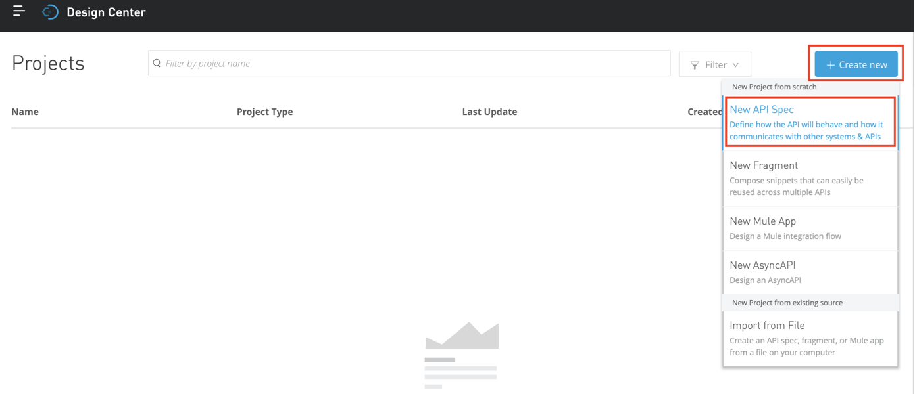

Figure 2.5 - Create new API Spec

1. On selecting, you’ll get a dialogue box as shown in the Figure 2.6, wherein you can enter the API Title following the naming convention. In this case, we’re designing a System API, which is evident from title having keyword sys, denoting System API.

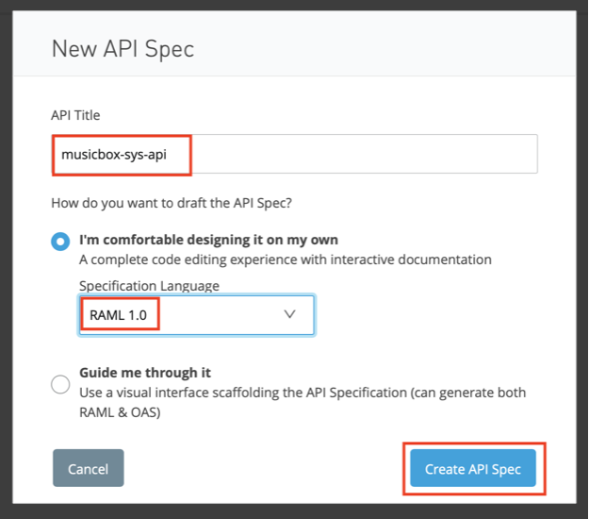

Figure 2.6 – Create new API Spec Dialog box

1. You can select the API Specification language from the dropdown list.

If you’re already familiar with the syntax of RAML/OAS, you can choose the first radio button which will let you design your API on your own, else you can opt for the second option which will help you navigate through every step while designing an API.

1. On clicking Create API Spec, you’ll be taken to API Design Canvas as seen in the following figure:

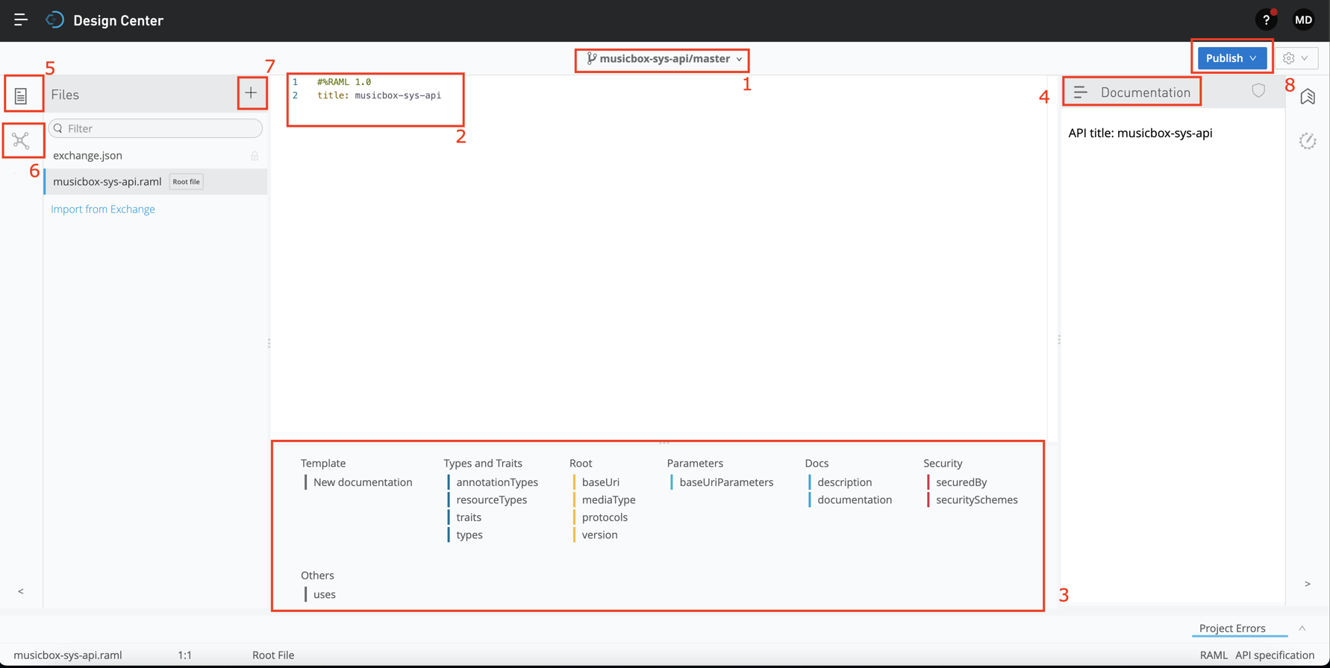

Figure 2.7 - API Design Canvas

The API Design Canvas consists of several components. Let us learn more about these:

* API Name and Branch: It is the same title which you’ve entered previously. You can also click on the down arrow and create a different branch if you wish to implement a branching strategy for RAML. By default, it’s the master branch.
* Editor: It’s the space where you can edit the root file and enter the elements of APIs like the root, security, methods, endpoints. You can also edit other file fragments like example.raml and datatype.raml = here.
* Suggestion palette: It gives you suggestions about various elements during your API design.
* Documentation: You can see all the information related to a particular endpoint in the Documentation section. You can also mock an endpoint from this section.
* Files: You can access all the newly created or imported files in the Files section.
* Dependency: In this section, you can import pre-existing APIs or fragments from the Exchange. The imported dependency will be eventually visible in the Files section.
* Create Files/Folders: You can create a new file or a folder to reorganize your API in smaller reusable fragments.
* Publish: Once your API is designed and validated, you can publish it to the Exchange using the Publish button.
* Settings: You can change your Import pre-existing APIs, you can also import APIs/fragments from Exchange, download your API as a zip file and share with external collaborators or rename/duplicate/delete the API (see Figure 2.8).

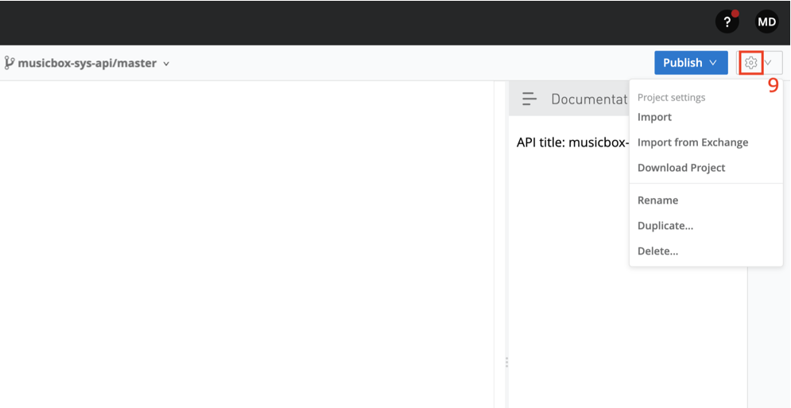

Figure 2.8 – API Design Center settings

…

Now let’s head on to our Editor and start editing our API specification:

In the root section, as seen in Figure 2.9), along with title you can add description, version, and other details..

1. To begin with, we’ll start with a basic songs endpoint and use GET Method. You can also refer songs as a resource or an endpoint:

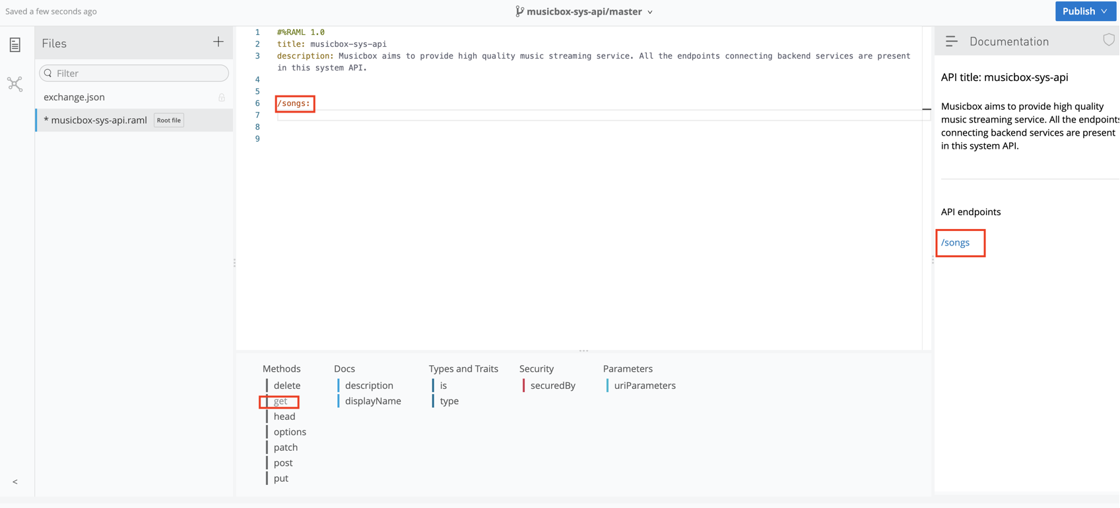

Figure 2.9 – Adding /songs endpoint in API Spec

At every stage, you can see the recommendations in the suggestion palette which helps you to design API quickly. Make sure you’re taking care of indentation while designing your API.

We have described the /songs endpoint and added the GET method (see Figure 2.10). We have specified the response code and body with an expected response as an example.

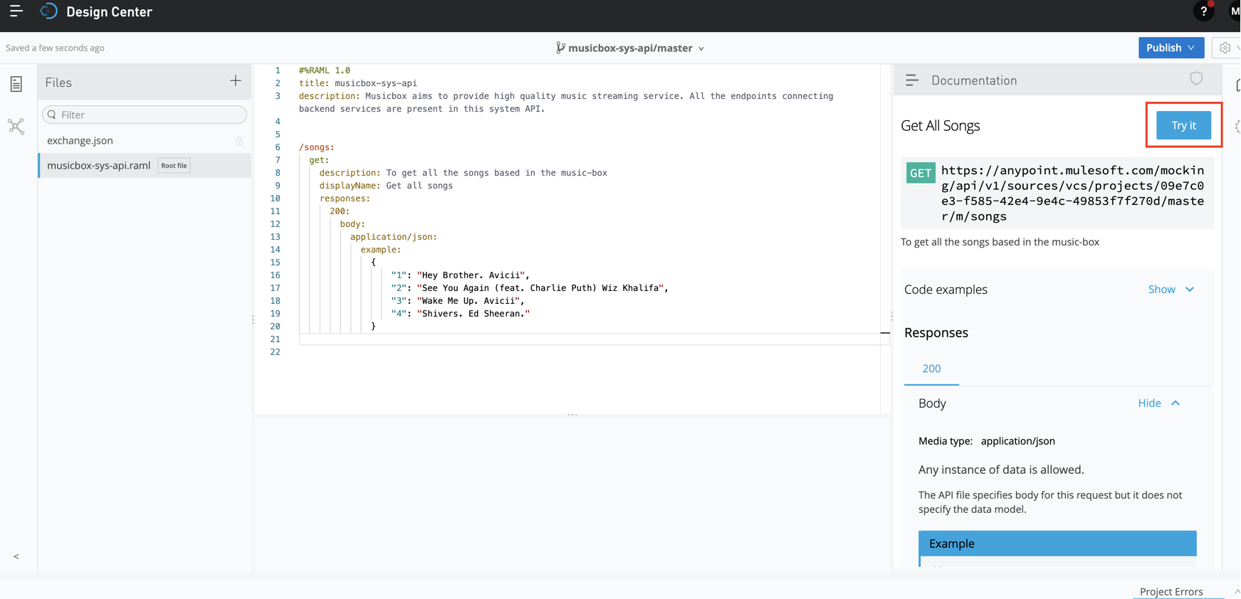

Figure 2.10 – Simulate GET endpoint using Try it

1. Similarly, you can try out designing a basic endpoint and later click on the Try it option (see Figure 2.10) on the top right of your documentation section to validate the response, if it meets your requirements.

Note

Here we’re just simulating the response based on the prototype we design. We will never receive an actual response from the backend systems, nor the security validations will be performed at the API Design level.

1. Similarly, we’ll add one more endpoint to post a new song based on the artist’s code as URI Parameter.

…

Here, it’s important to understand the difference between URI and Query parameter, as it’s often misunderstood and it’s equally important from interview and MCD certification point of view. Let us explore URI and Query parameters in detail.

URI parameter

Uniform resource identifier (URI), as the name suggests, is responsible for identifying a resource uniquely. For example, we can use it to search songs based on the song id: /song/{songId}

/songs:

/{songId}:

get:

description: To get all the songs based in the music-box

displayName: Get all songs getSongsExample

responses:

200:

body:

application/json:

example: {

"1": "Hey Brother. Avicii",

"2": "See You Again (feat. Charlie Puth) Wiz Khalifa",

"3": "Wake Me Up. Avicii",

"4": "Shivers. Ed Sheeran."

}

This is how an actual request would look like: http://<host>/song/234

So here /{songId} is the URI Parameter to fetch a particular song from the records.

Query parameter

It is used to query, filter, or sort the data based on a particular condition. You can remember the query parameter as the WHERE clause used in SQL.

It is passed at the end of the URL, followed by a ? and separated by &, if there are more than one query parameters. For example, we can use this toimplement pagination and fetch limited songs per page which were released in a particular year.

So here, year and limit are the query parameters (see Figure 2.11).

/songs?year=<year>&limit=<pageLimit>

This is how an actual request would look like: http://<host>/songs?year=2020&limit=20

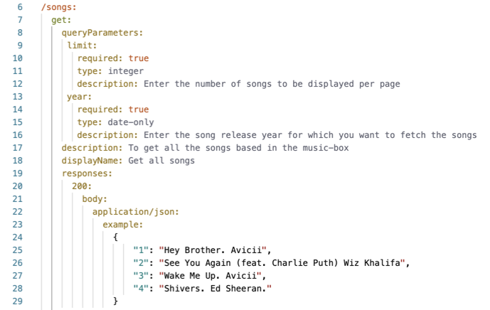

Figure 2.11 – Demonstrate Query Parameter

You can add more parameters like required, type, display name, description, and more to further describe your query parameter.

…

Getting back to our API Design, as you can see in the following figure, we’ve added a new endpoint /song/{artistCode} with POST method. This is responsible for creating a new record in the backend system.

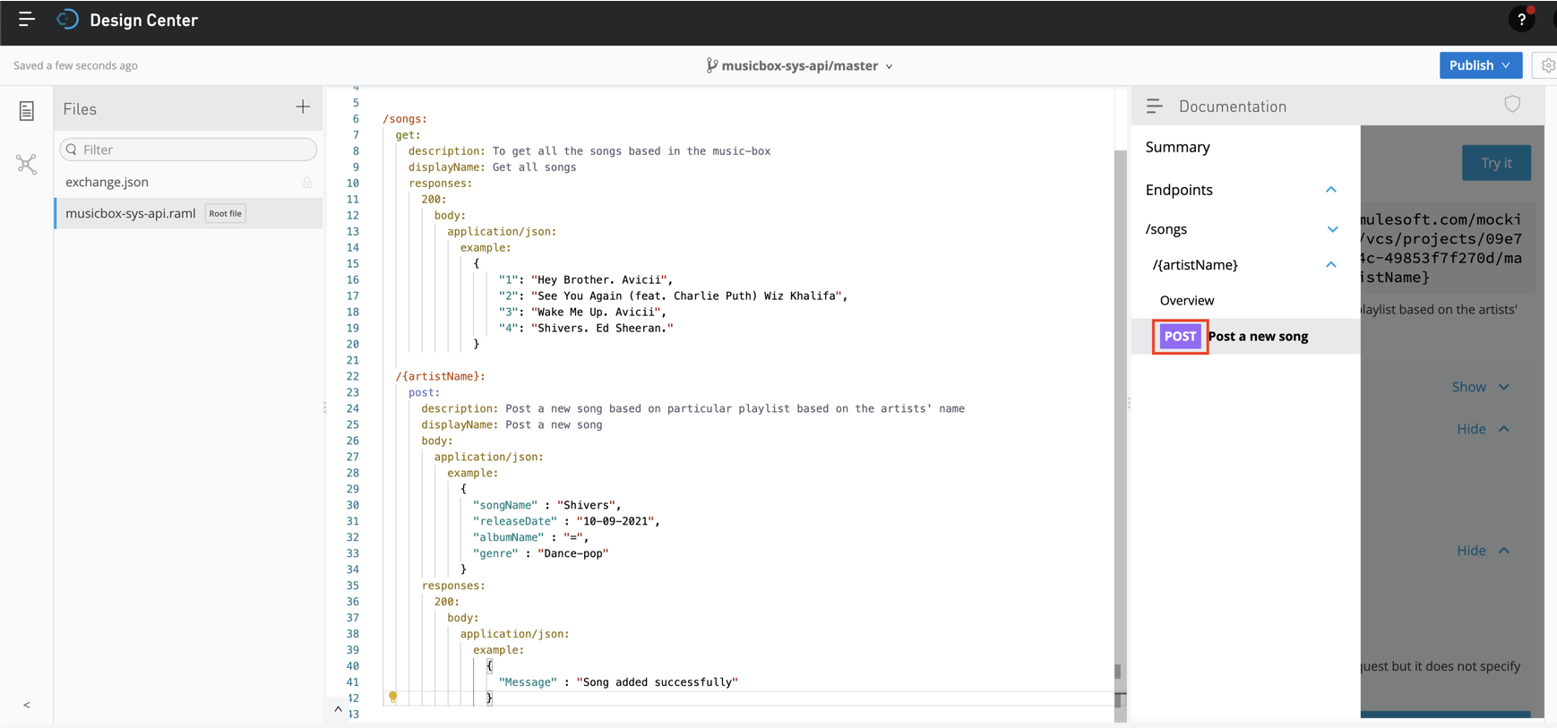

Figure 2.12 – Added a new endpoint to POST a new song

As it’s a POST method, we’ll also provide a request body like what is mentioned in the example, and we can expect a response 200 after it has successfully created a new song entry. You can set multiple status codes and its corresponding response.

Currently, in our RAML, we’ve added just two endpoints, and each has a single method; imagine if we have 20+ endpoints and each endpoint has at least two methods. In this case, the RAML would get pretty bulky.

Hence, to make RAML lightweight, flexible, and easily readable, we will externalize common, recurring components and then call them explicitly when required.

If you click on the + sign in the Left Panel of the Design Center, you get an option to create fragments and maintain a file structure.

Some of the commonly used API Fragments are:

* [Examples](https://github.com/raml-org/raml-spec/blob/master/versions/raml-10/raml-10.md#defining-examples-in-raml): We can exemplify the expected request-response structure or the data type using example files.
* [Data Type](https://github.com/raml-org/raml-spec/blob/master/versions/raml-10/raml-10.md#raml-data-types): They define the properties or data schema of a particular resource.
* [Resource Type](https://github.com/raml-org/raml-spec/blob/master/versions/raml-10/raml-10.md#resource-types-and-traits): Some of the resources have common structure which recurs at multiple instances. We can group these commonly occurring elements into a resource type and call it at multiple instances.
* [Trait](https://github.com/raml-org/raml-spec/blob/master/versions/raml-10/raml-10.md#resource-types-and-traits): We can group together a particular method whose characteristics are occurring repeatedly.
* [Library](https://github.com/raml-org/raml-spec/blob/master/versions/raml-10/raml-10.md#libraries): We can club together different fragments in a single library file. This comes handy when we’re dealing with a concise API. We can include Data Type, traits, security scheme etc. in a Library file.
* [Annotation Type](https://github.com/raml-org/raml-spec/blob/master/versions/raml-10/raml-10.md#annotations): It helps us to enhance the definition of endpoints by adding meta data and describing the API. It’s defined in a similar fashion to the datatype. Annotation type is restricted by allowedTargets, which limits the usage.
* [Overlays](https://github.com/raml-org/raml-spec/blob/master/versions/raml-10/raml-10.md#overlays)**:** They help to widen the API definition by further extending the details about the nodes. They focus on the non-behavioral aspects of an API.
* [Extension](https://github.com/raml-org/raml-spec/blob/master/versions/raml-10/raml-10.md#extensions): It is similar to Overlay, but they mainly focus on behavioral aspects of an API
* [User Documentation](https://github.com/raml-org/raml-spec/blob/master/versions/raml-10/raml-10.md#user-documentation): You can add documentation for your entire API Specification or a particular resource.
* [Security Scheme](https://github.com/raml-org/raml-spec/blob/master/versions/raml-10/raml-10.md#security-schemes): You can regroup all the security parameters & policies which will be applied throughout the API inside security scheme.

In order to make it concise, we’ll move the example into an example file and reference it explicitly in our root file.

1. Click on + in the right panel and create a new folder called musicboxAssets (see Figure 2.13).

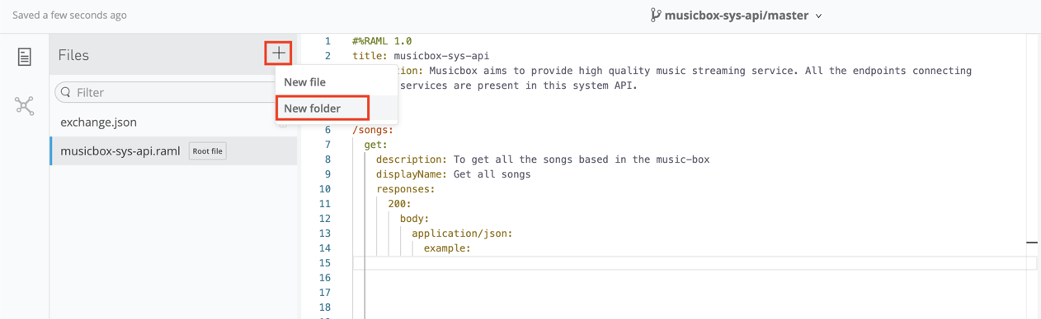

Figure 2.13 – Create a new folder

1. Create a new folder named examples inside musicboxAssets (see Figure 2.14).

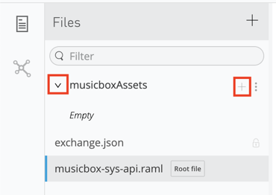

Figure 2.14 – Create a new folder for example

1. Create a new example file inside the example folder with name get-songs-example.raml (see Figure 2.15).

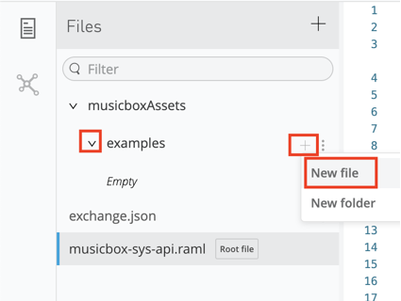

Figure 2.15 – Create a new example.raml file

1. Select your API Specification type and file type (Data Type, Example, Traits, and so on.) from the drop-down list and enter the file name as shown in the following figure:

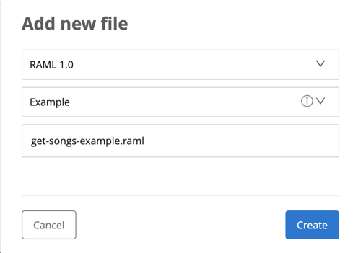

Figure 2.16 – Create new example file Dialog box

You can now see and empty example file get-songs-example.raml where we will transfer our example from the root RAML file.

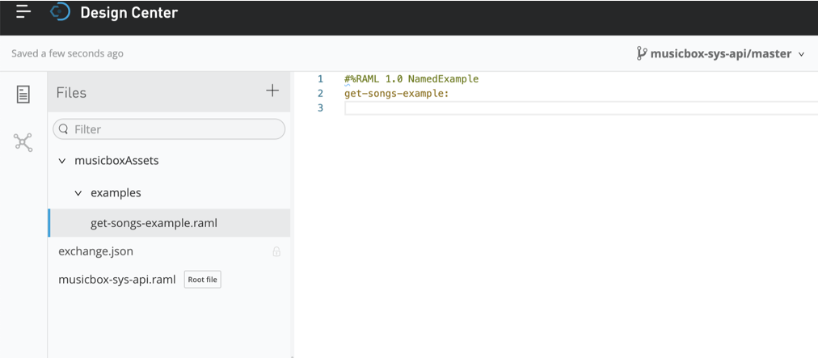

Figure 2.17 – Blank example file

1. Cut and paste the example from root RAML file to get-songs-example.raml file.…

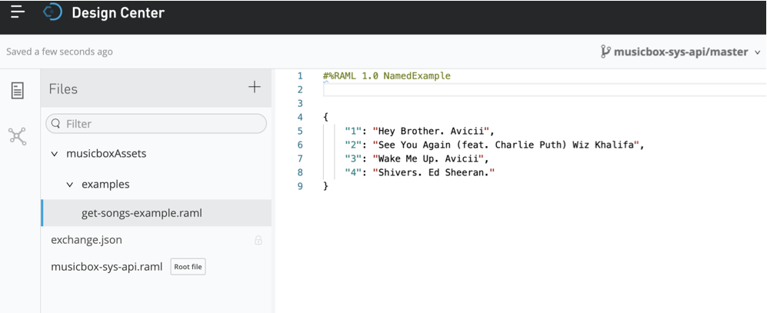

Figure 2.18 – Example moved from root file to example

1. Now, let’s reference our example file in our root RAML.

We can refer any file in root RAML using:!include <file-path>

1. To get an accurate file path, copy the path by clicking on the Copy path option of the respective file as shown in the following figure:

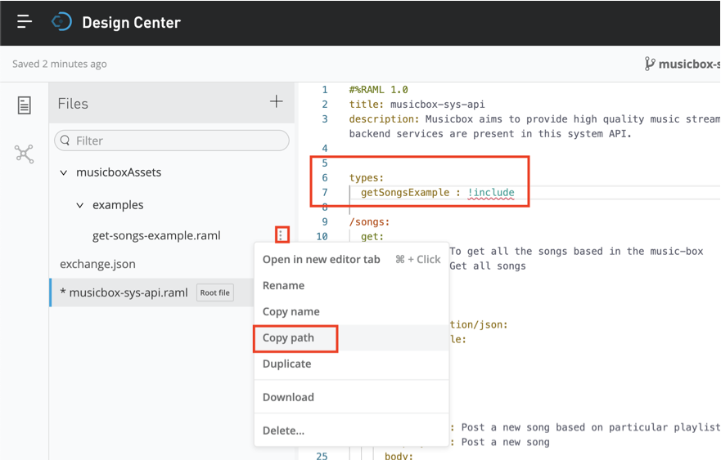

Figure 2.19 - Reference example file in root RAML file

…

1. Once the path is copied, reference it in root RAML file using !include.

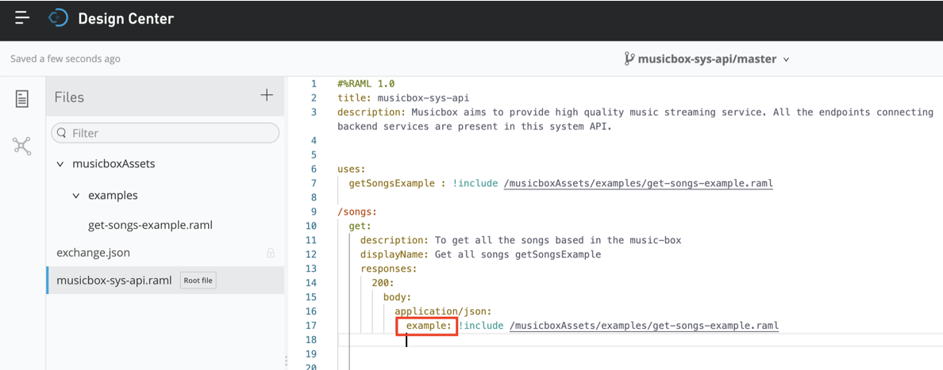

Figure 2.20 - Example file referenced in root RAML file

Similarly, we can reference example files for endpoint /song/{artistCode} with POST method.

As we have both request and response examples for POST method, we will further categorize the folder structure into requestExamples and responseExamples and save corresponding files and further reference it explicitly in our root RAML (see Figure 2.21):

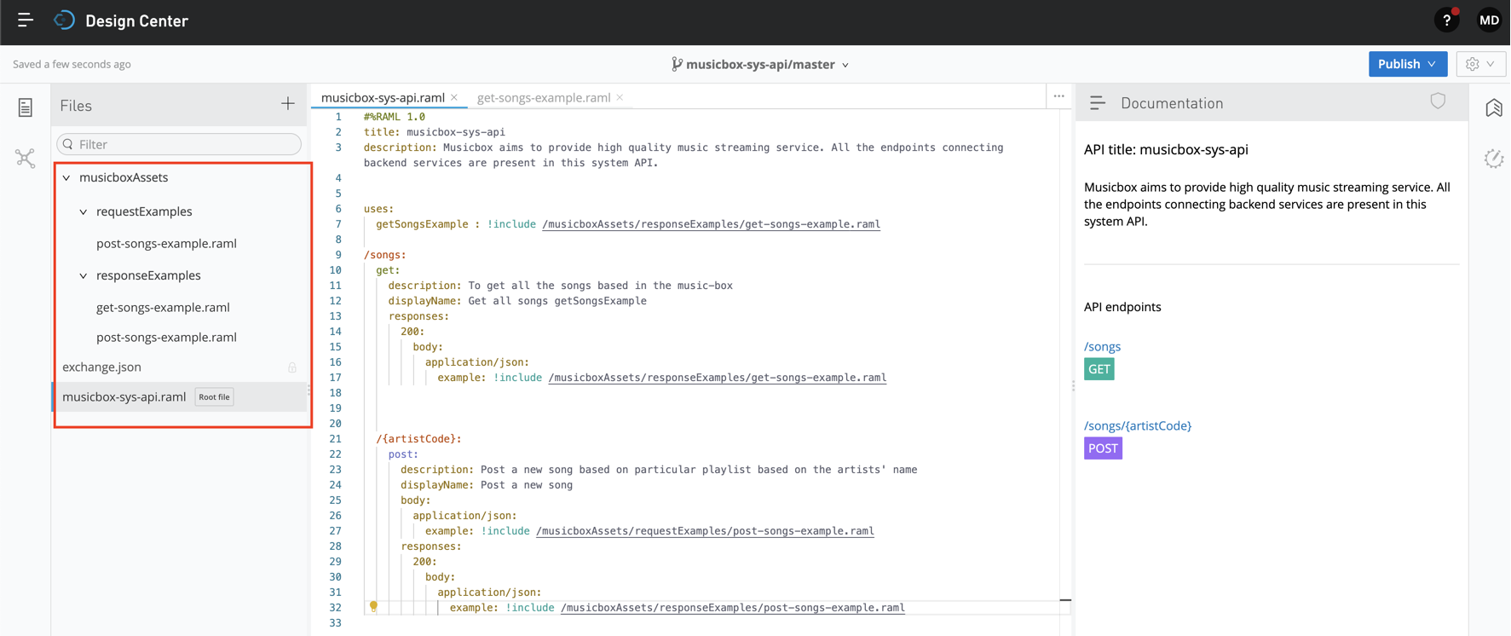

Figure 2.21 - Referencing example file for POST Method

We can follow a similar file structure for other fragments.

API mocking

As we’re following design first approach, API mocking helps you the simulate the API before implementing the API in the Anypoint Studio.

Once we are done with the API design, we can simulate the API by mocking the endpoint. Let’s follow the steps to mock our API

…

…

1. Click on the endpoint you wish to mock on the right-side panel.

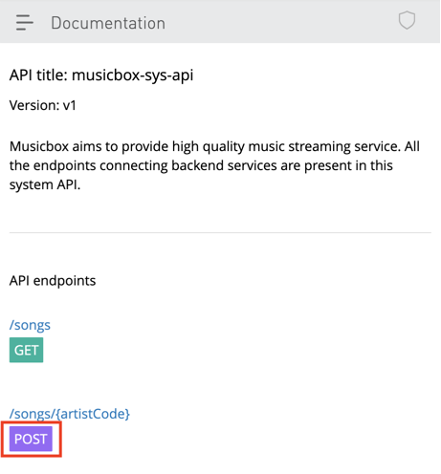

Figure 2.22 – Mocking POST method

1. You can find all the details related to your endpoint here. Click on the Try it button to mock the endpoint).

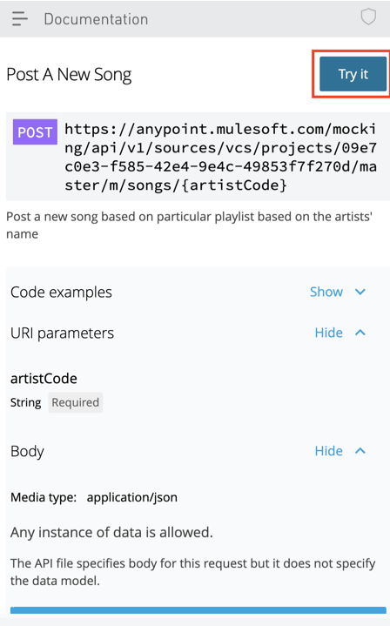

Figure 2.23 - Review Mocking endpoint information

1. Next, you can review information about your endpoint and fill in the missing details. 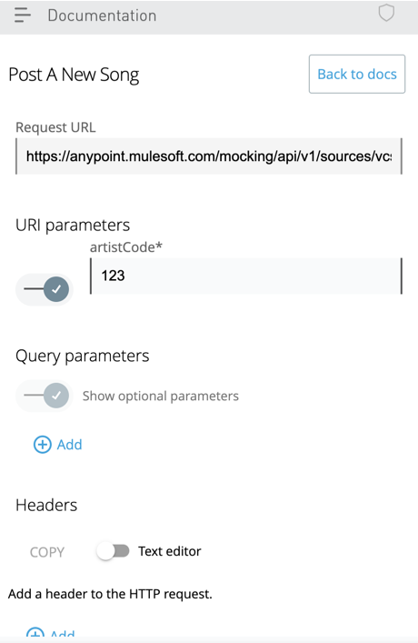

Figure 2.24 – Entering the request details before simulating the endpoint

1. Click on the send button once you’ve filled all the missing elements and reviewed the endpoint.

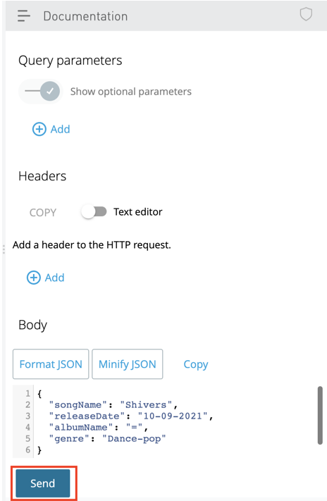

Figure 2.25 - Sending details to mock POST endpoint

1. Here, you can validate your response. Make any changes in the design specification if needed.

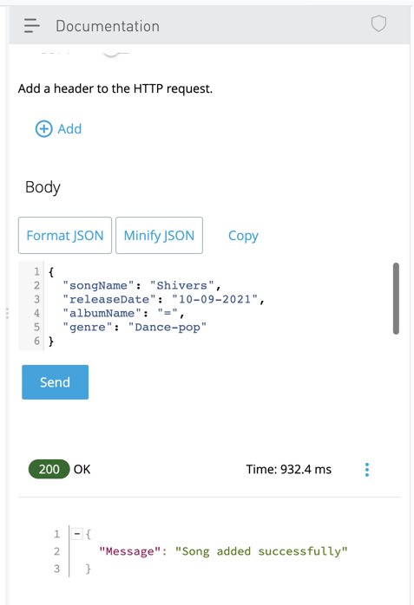

Figure 2.26 - Validating your API response

1. Once your API is finalized, you can publish the API to Exchange as shown in Figure 2.27).

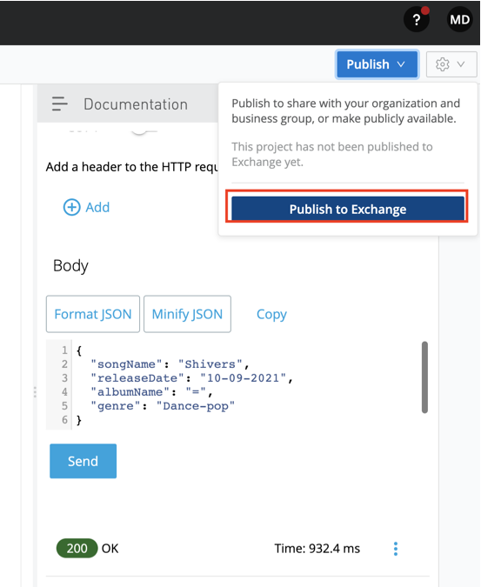

Figure 2.27 – Publishing your API to Exchange

1. Next, you can select the Asset version and API version (if already not mentioned in the root file). Select the LifeCycle State and click on Publish to Exchange(see Figure 2.28)**.**

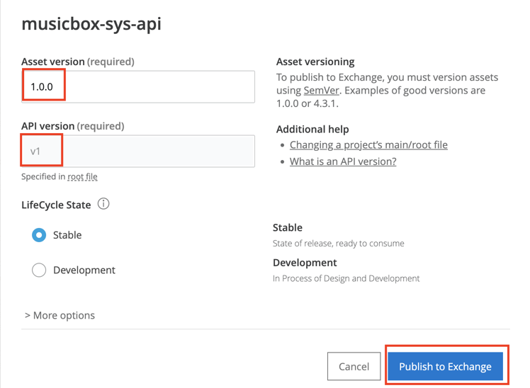

Figure 2.28 – Publishing your API to Exchange dialog box

1. Once you’ve published your API, you can view your API in Exchange.

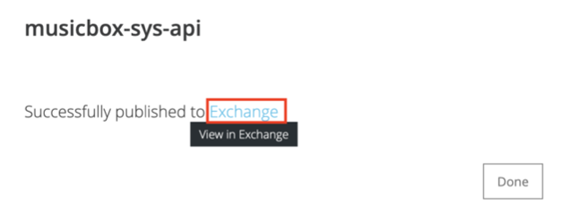

Figure 2.29 – API Successfully published to Exchange.

**////**

We have successfully designed a simple API, mocked an API and have also published it to Exchange thus completing the API design lifecycle.

Now we shall learn about some best practices and tips to standardize our API Design.

Best practices and tips

…

We shall now understand some of the API best practices & tips. In order to get started let’s learn some commonly used API Design naming conventions.

API design naming convention

Although every organization may have their own set of guidelines and best practices for API Design, here are a few commonly used naming conventions while designing an API. Adhering to the naming conventions throughout the API, makes it look consistent and standardized.

* Follow standard naming convention for all the APIs. Commonly used format is

<project_name><API-led-connectivity-layer>-api

For example, musicbox-sys-api

* Folder names should be in lower camel case.

For example, dataTypes, examples, musicboxAssets

* File names should be in lower snake case for readability purposes.
* For example, post-songs-datatypes.raml, get-songs-example.ramlRAML declarations should be in lower camel case.

For example, musicDataType, musicTraits

* Use noun instead of verb for your endpoints.

For example, /songs would be more accurate and not /getSongs as we already have HTTP verbs like GET, POST, PUT and so forth.

* Use plural form of noun for endpoints like /songs and not /song. It could be correct in case we wish to fetch a single object or delete a single object but it’s advisable to use plural form for the endpoint.

///

Now that we’ve learnt about the API design naming convention, let’s understand how we can optimize our API.

Optimizing your API design

APIs are considered as an asset of an organization. They not only add technical value but can also be used for monetization purpose. API monetization has been booming rapidly these days. Hence, a perfect API Design is a stepping stone to a successful application network. By ensuring that the API Design follows best practices and standards, we’re creating a sustainable API Network. In order to design an optimized API, here are some tips, tricks, and best practices:

* First and the most important, make sure your design is consistent across the different API layers and fragments.
* Divide your API into smaller fragments, thereby making it reusable and easily consumable. A concise and lightweight API is easy to read, less bulky, and the changes are saved quickly.
* Follow the naming convention standards throughout your API Design.
* Document your API so that it becomes easy for external collaborators, consumers to utilize the API.
* Add display name, description, and examples to your endpoint.
* Make sure security parameters are taken into consideration at API level.
* Mock your API service and get your request-response validated at an initial stage to avoid iterations in the later stages of application design.
* Be clear with API versioning.
* Use custom error codes for your endpoints.

////

We have now learnt about the best practices and tips involved in designing the API, let’s make sure to implement them using while APIs in future.

Summary

We have learnt the basics of API Lifecycle, API Designs; navigated through the REST & SOAP APIs, RAML & OAS. This chapter teaches us the fundamentals of API Design and the best practices to be followed.

As a MuleSoft Developer and Architect, I’d suggest you to not get overwhelmed by the different aspects of API Designs. It gets easier with practice. Make sure you’re following the best practices and the industry standards. Try to get hands-on with API Design as this chapter is important from MuleSoft Certification perspective too.

In the next chapter, we shall learn about MuleSoft’s Anypoint Studio – an Eclipse IDE for designing Mule application.

You can now attempt a practice API and answer a few quiz questions, to boost your API design confidence.

Practice

Music Box is an audio streaming platform that wants to build a mobile application for high-quality audio streaming, which will include songs and podcasts

As per the initial requirement phase, design a REST API (System and Process APIs) to achieve the following goals:

* Retrieve the list of all songs, podcasts, artists, genre, songs, collection based on a particular artist.
* Simulate a song by changing the artist’s name.
* Retrieve a paginated list of songs based on artists’ names.
* Delete songs added on a particular date.
* Add a new song to the collection.

Follow the API best practices and the industry standards. Make your API composable and concise by dividing it into smaller fragments. Try designing your own API and refer to the GitHub link for a solution.

Quiz

Take a moment to answer the following questions to serve as a recap of what you just learned in this chapter. The answers are provided at the end of the book.

1. What are the different stages of the API lifecycle?
2. What is the difference between data type, traits and library?
3. When should you use Query parameter and URI parameter?
4. How can you reference a file fragment in root RAML?
5. Why do we mock an API

Answers:

1. Design, Simulate, Feedback and Validate are the different stages of API Lifecycle.

2. Data type help us to define properties for a particular endpoint. Traits help you can define properties for a method. Library consist of mix of all fragments clubbed together.

3. If you want to filter or sort the the records based on some condition then we use query parameters else if you want to fetch a particular resource then we use URI parameter.

4. Using !include <filepath>

5. To simulate the API and validate the request and response of an endpoint.